TUBERCULOSIS DETECTION USING DEEP LEARNING
Vinayak Singh^{1[0000-0003-3052-588X]}, Harshvardhan GM^{1[0000-0003-3529-2931]}, Mahendra Kumar Gourisaria^{1[0000-0002-1785-8586]}
¹ School of Computer Engineering, KIIT Deemed to be University, Bhubaneswar, Odisha 751024, India
mkgourisaria2010@gmail.com
Abstract. Mycobacterium tuberculosis (TB) is responsible for a large number of deaths due to chronic infectious diseases globally. Majorly, TB can be classified into two categories named as Active and Latent Tuberculosis. Tuberculosis diag-nosis is a critical area and needs a high extent of accuracy for working. Mi-nor errors in diagnosis can result in disastrous repercussions. The ultimate goal of this paper is for detecting TB at right time and help combat the in-creasing number of cases by early treatment. In this paper we implement CNNs of different configurations on a dataset for binary classification and mainly focus on the objective function value obtained from different CNN models with a LVCEL, MVA, and TT. The objective function can be a use-ful tool for physicians and our medical community for correctly identifying a TB patient. Experimental evaluation of the best architecture shows that a maximum objective function value of 6.503, with validation accuracy score of 0.9671 and an AUC of 0.9733 in the Receiver Operating Characteristics (ROC) curve is achieved to correctly identify whether TB is present or not.
Keywords: Convolution neural network (CNN), Artificial -neural network (ANN), Deep Learning, Image Recognition, Machine Learning, Biomedical imaging
- Introduction
A major reason behind death among human beings is due to Tuberculosis. Tuberculosis is a dangerous contagious infectious and chronic disease that usually attacks our lungs and requires complex treatment. Tuberculosis is caused by infectious bacteria named Mycobacterium tuberculosis. According to stats, India is on top where most peoples are suffering from Tuberculosis(TB) and every year 480,000 deaths are recorded between 2006 and 2014 and India faced the loss of $340 Billion US dollars in the economy[1,2]. Over the world, 9 million peoples were suffering from TB in 2013 and most of the peoples approximately 80% were from Africa, South-East Asia Region, and the majority were poor and belonged to marginalized communities where health infrastructure was poor and weak. The reason behind these such large numbers was the lack of good healthcare infrastructures and poor resources and this reason is not acceptable as TB is curable and can be prevented. Most cases can be cured by Anti-Biotic but it takes approximately 6 to 9 months of medication. Majorly Tuberculosis can be classified into two areas i.e. Latent TB and Active TB. Chest X-rays [12] help to detect tuberculosis as there will be many abnormal findings like to infiltrate, any cavitary lesion, nodule with poorly defined margins and pleural effusion, and mediastinal lymphadenopathy which can be directly diagnosed by the physician by using Chest X-ray images. Due to modest sensitivity and specificity, and higher observer differences in reports of radiographs the use of chest radiography for TB diagnosis has been limited [3-5]. Machine learning and Deep learning play a crucial role in the medical field and computer vision [6-7]. Deep learning techniques like Artificial Neural Networks (ANNs) and Convolutional Neural Networks (CNNs) have improved the classification of images and detection of objects [8-9]. From a raw dataset, CNNs [10] can extract more characteristics and precise configurations of images for defining them in an efficient manner [11].
In this paper, we have discussed performance metrics achieved by different architectures where CNN and ANN models are used for training the dataset. All 15 architectures gave different maximum accuracy, minimum loss, and training time. All these parameters have been used for calculating the objective function value of every architecture and then we activated the neural network and evaluated the intermediate activation in CNN architecture with Keras. By the real-time deployment of tuberculosis automatic diagnosis, we achieve high accuracy by which we can save time using computing power to detect a tuberculosis patient. The rest of the paper is organized as follows:-2. Related Work, 3. Methods and Data 4. Experimentation and Results, 5.Conclusion and Future Work. We evaluated different CNN architectures and calculated the objective function value for every architecture and selected the ideal architecture that achieved the highest objective function value for the particular tuberculosis dataset used in section 4.
- Related Work
Nowadays as many fields are getting a major contribution from machine learning and deep learning techniques and work for medical workers are getting easier and convenient. As most of the research papers are more focused on deep learning techniques for tuberculosis detection [13-14].CNN's are playing a major role in the detection of diseases in the medical field where Chest X-ray images are used for detecting Pneumonia and Tuberculosis. Chhikara et al. (2020) used the Chest X-ray images (CXR) for evaluating the performance of pre-trained models like Xception, ResNet, and Inception for detection of pneumonia by implementing some preprocessing processes like gamma correction and filtering [15]. Accuracy of 82.09% was achieved by Hooda et al. for classification among a TB patient from a normal person by using deep learning technique for classifying CXR images [16]. DeTraC a transfer learning model made by Abbas et al. for dealing with the data imbalance for image classification in the medical field and Decompose, Transfer and Compose i.e. DeTrac architecture gained the highest accuracy of 99.8% for classifying the tuberculosis patients [17]. For classification among normal and TB patients, Nguyen et al. [18] used a DenseNet pre-trained model on a dataset provided by Shenzhen (CHN) and Montogomery County (MC) databases [19] by achieving AUC values of 0.94 and 0.82 respectively. Similarly, Lopes and Valiati performed TB detection using X-ray images on the same dataset of CHN and MC and achieved an accuracy of 80% on different pre-trained CNN models for classifying TB into positive and negative cases [22]. Yadav et al. achieved an accuracy of 94.89% by using transfer learning techniques for classification among CXR images [20].
Another example of machine learning is an interactive visualization tool which was developed by Pasa et al. for TB detection where the optimized deep learning architecture achieved an accuracy of 86.82% for Tuberculosis detection [21]. Hernandez et al. used CNN model ensembles for TB detection from X-Ray images and gained an accuracy of 86% and the model was based on the automatic classification method of TB [23]. Evalgelista and Guedes [24] approached chest X-ray images by using an intelligent pattern recognition using CNNs for detecting Tuberculosis and gained an accuracy of 88.76%. A CNN architecture was proposed by Abbas et al. on the Japanese Society of Radiological Technology (JSRT) database where they used a pre-trained model called as ImageNet model by using Transfer Learning and gained a very high accuracy [25]. Ahsan et al. used two techniques like image augmentation and without image augmentation for classifying TB datasets by using a pre-trained CNN architecture and gained accuracy of 81.25% and 80% [26]. Four different transfer learning techniques namely VGG-19, VGG-16, ResNet50, and GoogleNet was introduced on the TB dataset by Meeraj et al .which contained chest X-ray images for classification of TB where they explored the limits of different accuracies of various architectures [27]. Chowdhury et al. used a chest X-ray dataset for distinguishing viral pneumonia from Covid-19 pneumonia and normal cases by developing a trained model on the dataset [28]. Chang et al. on labelled tuberculosis culture images used transfer learning and achieved sensitivity and specificity of 99% and 98% [29].
In medical applications, TB detection with high accuracy from the chest radiographs i.e. X-ray images can be more versatile with the robust method can make computer diagnostic easy and more dependable. Although many techniques can be implemented on Tuberculosis there are several limitations like in previous implementations we can see that most of the papers were directed towards transfer learning techniques where they have used pre-trained models on various datasets and lack datasets and there was the repetition of datasets where a single dataset was used by many authors and accuracy achievement was high but lacked instability and few of them were performed on small scale and no different conditions were implemented so that we can check the stability of architectures. So many radiologists faced issues regarding the binary classification as there was not enough information or data for tuberculosis detection.
- Methods and Data
In this section, we will discuss the methodology we have used in the classification process of tuberculosis using Chest X-ray images of whether a person is suffering from TB or not. We also specify the dataset we have used for detection and also the technology with which we have done the experimentation and computations are also mentioned in this section. This section maps out as follows 3.1 Dataset Used, 3.2 Convolutional Neural Network (CNN) 3.3 Software and Hardware.

  - Dataset Used
The Chest X-ray images for Tuberculosis Detection of patients were collected from Kaggle and were deployed by Tawsifur Rahman, Amith Khandakarand, Dr. Muhammad Chowdhury. They collected all the images from various datasets like the NLM dataset, Belarus dataset, NIAID TB dataset, and RSNA CXR dataset and gathered around 7000 images [39]. A sample difference between a positive infective patient and a normal person is shown in Fig.1. Table 1 describes the amount of Chest X-ray images taken for training, validation, and testing of the model.
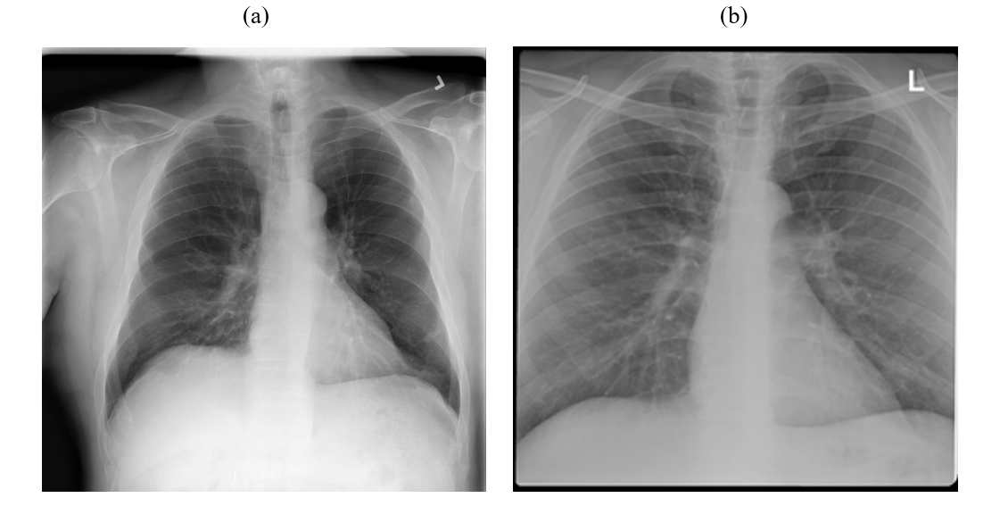
Fig 1. (a) Chest-X Ray of a normal person, and (b) of a tuberculosis positive patient.
Table 1. Dataset distribution and splitting of images taken into training and testing.
 | Tuberculosis | Normal
Training | 2800 | 2800
Testing | 350 | 350
Validation | 350 | 350
Total | 3500 | 3500

3.2 Convolutional Neural Network (CNN)
Convolutional Neural Network [30] is the backbone of deep learning and machine learning technique and CNN is a commonly used framework model which were proposed by Yan LeCunn in 1998 and it changed the approaches for the training of models. For classifying objects and images CNN works as operators for classification under different conditions. There are many applications of CNN architectures decoding facial recognition [31], malaria detection [32], chronic diseases and health care sector [33, 34], earthquakes prediction [35], and many more [36-38]. CNN's are composed of 4 main types of layers – Convolutional, Max-Pooling, Flattening, and Full-Connection. The main objective of Convolutional layers is to extract features by using feature detectors i.e. are known as kernels which are in form of a 2-D matrix. By building the local relationship between pixels of raw images there is a formation of a feature map and this relationship is used for finding the difference between the two images. From convolutional neural networks, we can state that it must be related to the convolutional theorem.

So, mathematically we can explain the convolutional layer in terms of convolutional theorem and that can be define as
 | $$(x*y)(a)≜ \underset{x\left(a\right)*y\left(a\right)}{\underbrace{\int_{-∞}^{∞}{x\left(Ψ\right)y\left(a-Ψ\right)dΨ}}}$$ | (1)

Where the two functions are $x\left(a\right)$and $y(a)$ of a continuous variable $x$.For better training and execution of the model, the architecture needs to be more heavy and rich in parameters. Multi CNN layers contain large parameters and there are many convolutional layers with various operations. The First Convolutional layer is implemented with Max-Pooling where max-pooling reduces the parameters and makes parameters measurable and prevents data from getting overfit. So multiple layers contain multiple max-pooling layers after every convolutional layer. Mathematically, multiple layers can be represented as,

 | $$\underset{a}{\underbrace{X*X*X………*X*X}}=Xᵃ$$ | (2)
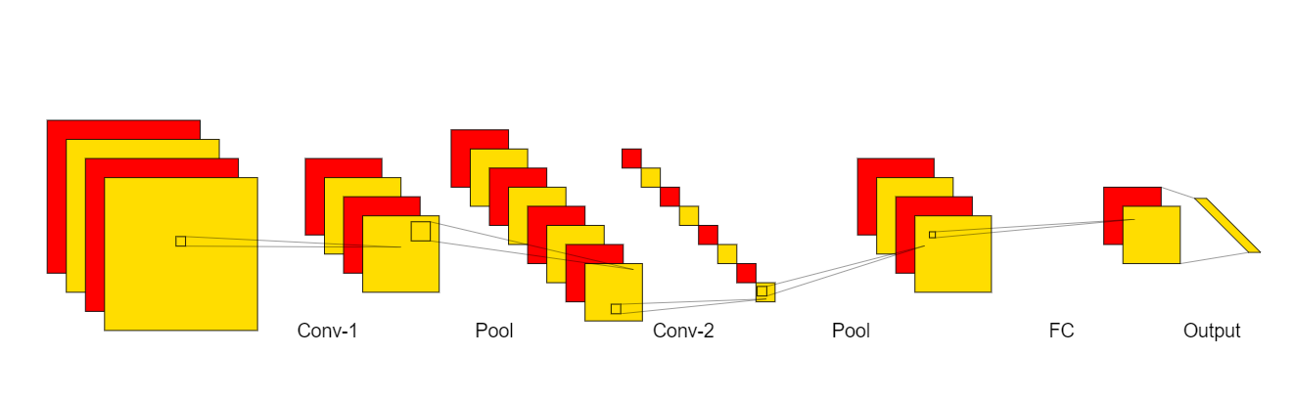
Fig. 3. Convolutional Architecture of a 2- layered CNN model.
After the implementation of max-pooling, there is an essential process of Flattening which helps for flattening the 2-D matrices kernels into a vertical array that needs to be fed into an ANN i.e. Dense Layer After which we connect all the layers named as Fully Connected Layers (FCL). After this, the values are reflected as output from the fully convolutional neural network. Fig 3. Shows a 2 layered full CNN connection.
Various CNN architectures trained for this machine learning analysis Python 3 with the Keras and TensorFlow were used with a jupyter notebook. Hardware workstation is with Intel i5 $8^{th}$ generation and 16 GB RAM.
- Experimentation and Results
In this section, we elaborate everything regarding experimentation performed on the dataset through different CNN and ANN architectures that contains different parameters and we selected the best model based on stability and reliability for classification among TB patient from the normal person. We divide this section as 4.1 Experiments and Analysis, 4.2. Result of Selected Architecture.

  - Experiments and Analysis
We implemented different regularization conditions in different CNN architectures for finding the best model. For the different implementations, we had various parameters such as the number of Convolutional layers and Artificial layers, Batch Normalization, Dropout, and regularization parameters like L1, L2, input sizes of images, kernel sizes, pooling matrix sizes, and feature detection and analogize all the architecture based on Objective Function Value obtained from different architectures and Objective Function Value is based on maximum validation accuracy, least validation cross-entropy loss and training time. The best model was evaluated on Objective Function Value which can be expressed as

 | $$Objective Function Value=\frac{MVA}{TT+LVCEL }$$ | (3)

All information regarding the all different 15 CNN architectures with their maximum validation accuracy, least validation cross-entropy loss, and training time in seconds are included in Table 3, and Table 2 contains all the meaning of abbreviations used in Table 3. Structure-based on minimum LVCEL, maximum MVA, and TT of every architecture is shown in Fig. 4. Fig. 5 plots the training accuracy and Fig. 6 plots the validation cross-entropy loss of each architecture concerning each epoch. From Table 3 we observed that architecture 9 performed poorly concerning MVA and LVCEL as it had the least objective function value of 0.8400. This might happened due to Dropout as when Dropout is implemented it reduces the trainable training data parameters which may lead to a drop in accuracy which leads to a fall in objective function value and restricted the model from building a relationship with the dataset. We also noticed that training time was heavily impacted by the change in image input shapes. We can say MVA, TT also depends on input sizes as in architecture 1, 3, 4, 7, and 8 where image size was (64, 64) which reduced the training time, and thus we can conclude that TT depends on IS. We can also say TT is inversely proportional to the number of layers as More number of layers the computational work increases and training time will increase and if the architecture is not heavily parameterized then TT will be less load will increase on training the neural network increases when an intensive task is performed. Fig 4(c) changes drastically when there is a change in architecture layers like if w increase or decreases the layers there is an impact on TT of CNN and ANN architecture but there is not drastically change in LVCEL and MVA.
However, the maximum objective function value was obtained by model 4 which was 6.503 and the minimum objective function value of 0.84 was obtained by model 9. By this we can conclude that normal and small CNN and ANN architectures perform more stable and better with good accuracy and high objective function value. Model will either overfit or underfit if we implement more features and layers. So for further consideration, we have taken model 4 as an ideal architecture to evaluate model performance on the tuberculosis dataset in the next section.
Table 2. Abbreviations used in Table 3.
Abbreviation | Meaning
CL  AL  L1  L2  BN  DO  IS  FD  KS  PS  TT  LVCEL  MVA | The number of CNN Layers in an architecture.  The number of ANN Layers in an architecture.  Level 1 regularizations  Level 2 regularizations  Batch Normalization  Dropout  Input Size of image (64x64 or 128x128)  Feature detected in a convolutional layer, layer-wise.  Kernel Sizes for each convolutional layer, layer-wise.  Pooling Sizes followed by every convolutional layer always assumed to be a square matrix.  Time taken in seconds to train the model.  Least Validation Cross-Entropy Loss achieved during training.  Maximum Validation Accuracy was achieved during training.
Table 3. Performance of 15 different CNN architectures on various parameters.

S. no. | CL | AL | Regularization |  |  |  | IS | FD | KS | PS | LVCEL | MVA | TT
 |  |  | L1 | L2 | BN | DO
1 | 2 | 3 | ✖ | ✖ | ✖ | ✖ | (64,64) | {64,32} | {9,3} | {4,2} | 0.1001 | 0.9700 | 1181
2 | 2 | 4 | ✖ | ✖ | ✔ | ✖ | (128,128) | {64,32} | {9,3} | {4,2} | 0.0977 | 0.9714 | 2868
3 | 2 | 4 | ✖ | ✖ | ✖ | ✔ | (64,64) | {64,32} | {9,3} | {4,2} | 0.1324 | 0.9543 | 1321
4 | 3 | 3 | ✖ | ✖ | ✖ | ✖ | (64,64) | {64,32,16} | {6,3,3} | {2,2,2} | 0.1116 | 0.9671 | 1074
5 | 3 | 4 | ✖ | ✖ | ✖ | ✖ | (128,128) | {128,64,32} | {9,6,3} | {4,4,2} | 0.0945 | 0.9714 | 2331
6 | 3 | 5 | ✖ | ✖ | ✔ | ✔ | (128,128) | {128,64,32} | {9,6,3} | {4,4,2} | 0.1150 | 0.9657 | 2292
7 | 4 | 4 | ✖ | ✖ | ✖ | ✖ | (64,64) | {64,64,32,16} | {6,6,3,3} | {2,2,2,2} | 0.1071 | 0.9686 | 1120
8 | 4 | 4 | ✖ | ✖ | ✔ | ✔ | (64,64) | {64,64,32,16} | {6,6,3,3} | {2,2,2,2} | 0.1473 | 0.9571 | 998
9 | 4 | 5 | ✖ | ✖ | ✖ | ✔ | (128,128) | {128,64,32,16} | {9,6,3,3} | {4,2,2,2} | 0.1323 | 0.9614 | 3045
10 | 4 | 6 | ✖ | ✖ | ✖ | ✖ | (128,128) | {128,64,32,16} | {9,6,3,3} | {4,4,2,2} | 0.1124 | 0.9743 | 2290
11 | 5 | 5 | ✖ | ✖ | ✖ | ✖ | (128,128) | {128,64,64,32,16} | {9,6,6,3,3} | {4,2,2,2,2} | 0.0962 | 0.9629 | 1706
12 | 5 | 6 | ✔ | ✖ | ✖ | ✔ | (128,128) | {128,64,64,32,16} | {9,66,,3,3} | {4,2,2,2,2} | 0.0978 | 0.9743 | 1982
13 | 5 | 7 | ✖ | ✔ | ✖ | ✖ | (128,128) | {128,64,64,32,16} | {9,6,3,3,3} | {2,2,2,2,2} | 0.1077 | 0.9614 | 1905
14 | 6 | 7 | ✔ | ✖ | ✔ | ✔ | (128,128) | {128,128,64,64,32,16} | {9,6,6,3,3,3} | {2,2,2,2,2,2} | 0.1304 | 0.9571 | 1662
15 | 6 | 8 | ✔ | ✔ | ✖ | ✔ | (128,128) | {128,128,64,64,32,16} | {9,6,6,3,3,3} | {2,2,2,2,2,2} | 0.1418 | 0.9571 | 1743
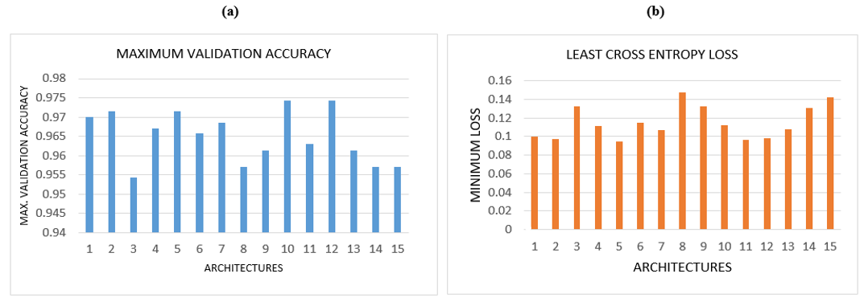Fig. 4. (a) Maximum Validation Accuracy (MVA) for each architecture. (b) Least Cross-Entropy Loss (LVCEL) for each architecture.
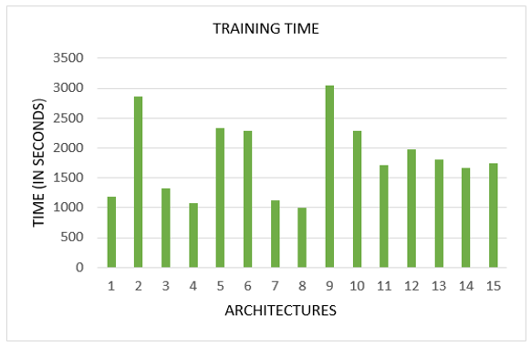
Fig. 5.Training Time (TT) for each architecture.
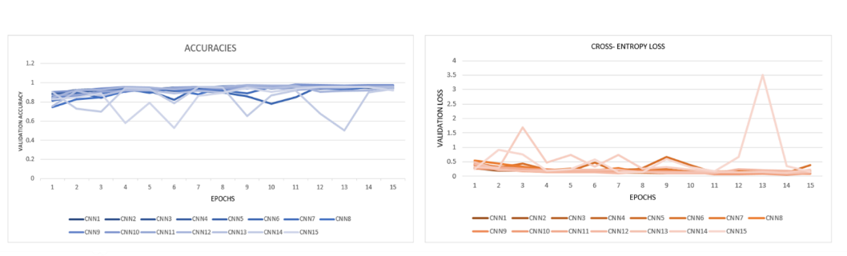
Fig. 6. (L)Validation accuracy training curve for each architecture per epoch. (R) Validation cross-entropy loss training curve for each architecture per epoch.

  - Result of Selected Architecture
We selected architecture 4 as the model performance was excellent and achieved the highest objective function value. An evaluation metrics we calculated the confusion matrix and calculated the sensitivity, specificity, precision, F1 score, and MCC i.e. Mathew Correlation Coefficient.
 | $$Sensitivity= {TP}/{(TP+FN)}$$ | (4)

 | $$Specificity= TN / (FP + TN)$$ | (5)

 | $$Precision= TP / (TP + FP)$$ | (6)

 | $$F1 Score =2TP / (2TP + FP + FN)$$ | (7)

 | $$MCC =\frac{TP x TN - FP x FN}{√((TP+FP)*(TP+FN)*(TN+FP)*(TN+FN))}$$ | (8)

Where TP, TN, FP, and FN are True Positive, True Negative, False Positive, and False Negative respectively. See Fig. 7 illustrates the confusion matrix of the selected model where testing was done on 700 images where TN=339 TP= 335 FN = 11 FP = 15. From equations 4, 5, 6, 7, and 8 we calculated $Senstivity=0.9576$ $Specificity=0.9682$ $, Precision=0.9686$ $, F1-Score=0.9631$ $, MCC=0.9258$.
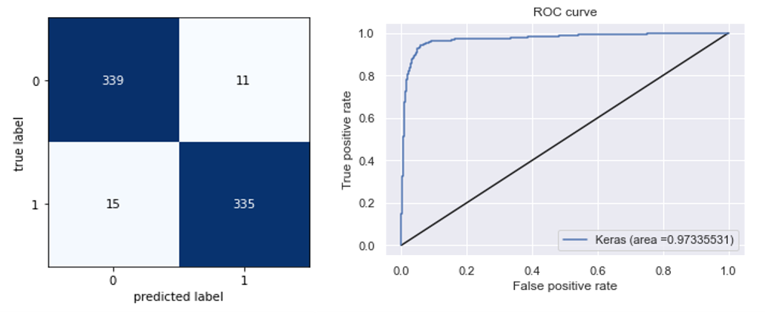
Fig. 8. (L)The confusion matrix for architecture 4 (see Table 3). (R) The receiver-operating characteristics (ROC) curve for 4th CNN architecture. The area under the curve is calculated to be 0. 973355 units
All five metrics are above 90% this indicates that our model was accurate and performed excellently in diagnosing the positive TB cases and negative TB cases. Moreover, the ROC curve is illustrated in See Fig. 8 where the area under the curve (AUC) was found to be 0.973355 which is very good. These metrics are excellent and are comparable with various architectures based on Tuberculosis detection using Chest X-ray images.
5. Conclusions and Future Work
In this paper, we make a best effort to find out the best approach for tuberculosis detection using Chest X-ray Images by comparing all the 15 different CNN and ANN architectures based on performance and we selected an ideal model based on maximum objective function value which is easy to train and detect tuberculosis faster and more reliable manner. The metrics of selected architecture compared to other ones are simpler as if architecture gets complex the training time gets increased drastically but accuracy and loss were not changing much as compared to TT. We admit architecture 4 performed best and can gain more stability and accuracy if we do small adjustments and experimented upon more.
Future work of Tuberculosis detection through various algorithms as there are already many papers on Transfer learning we can create efficient and stable CNN architectures by user method. There can also be the implementation of many conditions on any model for finding the best suitable condition for training and executing our model. So tuberculosis is a sensible case and can give better outcomes via various algorithms under different conditions and can give the better result of diagnosing tuberculosis patients and normal peoples.
References
- The organization, W.H.: Global Tuberculosis Control: WHO Report. World Health Organization (2009)
- Central TB Division, Directorate General of Health Services, M.o.H.w.F.W.N.B.N.D....: NATIONAL STRATEGIC PLAN FOR TUBERCULOSIS ELIMINATION 20172025. Central TB Division, Directorate General of Health Services, Ministry of Health with Family Welfare, Nirman Bhavan, New Delhi 110 108 (2017)
- S. Jaeger, A. Karargyris, S. Antani, and G. Thoma, "Detecting tuberculosis in radiographs using combined lung masks," in Engineering in Medicine and Biology Society (EMBC), 2012 Annual International Conference of the IEEE, 2012, pp. 4978-4981.
- S. Jaeger, S. Antani, and G. Thoma, "Tuberculosis screening of chest radiographs," SPIE Newsroom, 2011.
- S. Ya-Lin and Y. Yang, "Localization algorithm and implementation for focal of pulmonary tuberculosis chest image," in Machine Vision and Human-Machine Interface (MVHI), 2010 International Conference on, 2010, pp. 361-364.
- Lundervold, A. S., & Lundervold, A. (2019). An overview of deep learning in medical imaging focusing on MRI. Zeitschrift für Medizinische Physik, 29(2), 102-127.
- van Ginneken, B. (2017). Fifty years of computer analysis in chest imaging: rule-based, machine learning, deep learning. Radiological physics and technology, 10(1), 23-32.
- Ker, J., Wang, L., Rao, J., & Lim, T. (2017). Deep learning applications in medical image analysis. Ieee Access, 6, 9375-9389.
- Neelapu, R., Devi, G. L., & Rao, K. S. (2018). Deep learning-based conventional neural network architecture for medical image classification. Traitement du Signal, 35(2), 169-182.
- LeCun, Y., Kavukcuoglu, K., Farabet, C.: Convolutional networks and applications in vision. In: IEEE international symposium on circuits and systems, pp. 253-256. IEEE,(2010).
- Abd-Ellah, M. K., Awad, A. I., Khalaf, A. A., Hamed, H. F.: Two-phase multi-model automatic brain tumor diagnosis system from magnetic resonance images using convolutional neural networks. EURASIP Journal on Image and Video Processing (1), 97 (2018).
- Van Cleeff, M. R. A., Kivihya-Ndugga, L. E., Meme, H., Odhiambo, J. A., & Klatser, P. R. (2005). The role and performance of chest X-ray for the diagnosis of tuberculosis: a cost-effectiveness analysis in Nairobi, Kenya. BMC infectious diseases, 5(1), 1-9.
- Stirenko, S., Kochura, Y., Alienin, O., Rokovyi, O., Gordienko, Y., Gang, P., & Zeng, W. (2018, April). Chest X-ray analysis of tuberculosis by deep learning with segmentation and augmentation. In 2018 IEEE 38th International Conference on Electronics and Nanotechnology (ELNANO) (pp. 422-428). IEEE.
- Yadav, O., Passi, K., & Jain, C. K. (2018, December). Using deep learning to classify X-ray images of potential tuberculosis patients. In 2018 IEEE International Conference on Bioinformatics and Biomedicine (BIBM) (pp. 2368-2375). IEEE.
- Chhikara, P., Singh, P., Gupta, P., & Bhatia, T. (2020). A deep convolutional neural network with transfer learning for detecting pneumonia on chest X-rays. In Advances in Bioinformatics, Multimedia, and Electronics Circuits and Signals (pp. 155-168). Springer, Singapore.
- R. Hooda, S. Sofat, S. Kaur, A. Mittal, and F. Meriaudeau, ``Deep-learning: A potential method for tuberculosis detection using chest radiography,'' in Proc. IEEE Int. Conf. Signal Image Process. Appl. (ICSIPA), Kuching, Malaysia, Sep. 2017, pp. 497_502.
- A. Abbas, M. M. Abdelsamea, and M. M. Gaber, ``DeTrac: Transfer learning of class decomposed medical images in convolutional neural networks,'' IEEE Access, vol. 8, pp. 74901_74913, 2020.
- Q. H. Nguyen, B. P. Nguyen, S. D. Dao, B. Unnikrishnan, R. Dhingra, S. R. Ravichandran, S. Satpathy, P. N. Raja, and M. C. H. Chua, ``Deep learning models for tuberculosis detection from chest X-ray images,'' in Proc. 26th Int. Conf. Telecommun. (ICT), Apr. 2019, pp. 381_386.
- S. Jaeger, S. Candemir, S. Antani, Y.-X. Wang, P.-X. Lu, and G. Thoma, ``Two public chest X-ray datasets for computer-aided screening of pulmonary diseases,'' Quant. Imag. Med. Surg., vol. 4, no. 6, p. 475, 2014.
- O. Yadav, K. Passi, and C. K. Jain, ``Using deep learning to classify X-ray images of potential tuberculosis patients,'' in Proc. IEEE Int. Conf. Bioinf. Biomed. (BIBM), Dec. 2018, pp. 2368_2375.
- F. Pasa, V. Golkov, F. Pfeiffer, D. Cremers, and D. Pfeiffer, ``Efficient deep network architectures for fast chest X-ray tuberculosis screening and visualization,'' Sci. Rep., vol. 9, no. 1, pp. 1_9, Dec. 2019.
- U. K. Lopes and J. F.Valiati, ``Pre-trained convolutional neural networks as feature extractors for tuberculosis detection,'' Comput. Biol. Med., vol. 89, pp. 135_143, Oct. 2017.
- A. Hernandez, A. Panizo, and D. Camacho, ``An ensemble algorithm based on deep learning for tuberculosis classi_cation,'' in Proc. Int. Conf. Intell. Data Eng. Automated Learn., Manchester, U.K., 2019, pp. 145_154.
- L. G. C. Evalgelista and E. B. Guedes, ``Computer-aided tuberculosis detection from chest X-ray images with convolutional neural networks,'' in Proc. Anais do XV Encontro Nacional de Inteligência Artif. e Computacional (ENIAC), Oct. 2018, pp. 518_527
- A. Abbas, M. M. Abdelsamea, and M. M. Gaber, ``DeTrac: Transfer learning of class decomposed medical images in convolutional neural networks,'' IEEE Access, vol. 8, pp. 74901_74913, 2020.
- M. Ahsan, R. Gomes, and A. Denton, ``Application of a convolutional neural network using transfer learning for tuberculosis detection,'' in Proc. IEEE Int. Conf. Electro Inf. Technol. (EIT), May 2019, pp. 427_433.
- S. S. Meraj, R. Yaakob, A. Azman, S. N. Rum, A. Shahrel, A. Nazri, and N. F. Zakaria, ``Detection of pulmonary tuberculosis manifestation in chest X-rays using different convolutional neural network (CNN) models,'' Int. J. Eng. Adv. Technol. (IJEAT), vol. 9, no. 1, pp. 2270_2275, Oct. 2019.
- M. E. H. Chowdhury, T. Rahman, A. Khandakar, R. Mazhar, M. A. Kadir, Z. B. Mahbub, K. R. Islam, M. S. Khan, A. Iqbal, N. Al-Emadi, M. B. I. Reaz, and T. I. Islam, ``Can AI help in screening viral and COVID-19 pneumonia?'' 2020, arXiv:2003.13145. [Online]. Available: http://arxiv.org/abs/2003.13145
- R.-I. Chang, Y.-H. Chiu, and J.-W. Lin, ``Two-stage classi_cation of tuberculosis culture diagnosis using a convolutional neural network with transfer learning,'' J. Supercomput., vol. 76, pp. 8641_8656, Jan. 2020
- Albawi, S., Mohammed, T. A., & Al-Zawi, S. (2017, August). Understanding of a convolutional neural network. In 2017 International Conference on Engineering and Technology (ICET) (pp. 1-6). Ieee.
- Sajjad, M., Zahir, S., Ullah, A., Akhtar, Z., Muhammad, K.: Human behavior understanding in big multimedia data using CNN based facial expression recognition. Mobile networks and applications, 1-11 (2019).
- Gourisaria, M. K., Das, S., Sharma, R., Rautaray, S. S., Pandey, M: A Deep Learning Model for Malaria Disease Detection and Analysis using Deep Convolutional Neural Networks. International Journal of Emerging Technologies 11(2), 699-704 (2020).
- Mishra, S., Pandey, M., Rautaray, S. S. Gourisaria, M. K.: A Survey on Big Data Analytical Tools & Techniques in Health Care Sector. International Journal on Emerging Technologies 11(3), 554-560 (2020).
- Anand, A., Anand, H., Rautaray, S.S., Pandey, M. Gourisaria, M.K.: Analysis and prediction of chronic heart diseases using machine learning classification models. International Journal of Advanced Trends in Computer Science and Engineering 9(5), 8479-8487 (2020).
- Anand, A., Anand, H., Rautaray, S.S., Pandey, M. Gourisaria, M.K.: Analysis and prediction of chronic heart diseases using machine learning classification models. International Journal of Advanced Trends in Computer Science and Engineering 9(5), 8479-8487 (2020).
- Crounse, K. R., Yang, T., Chua, L. O.: Pseudo-random sequence generation using the CNN universal machine with applications to cryptography. In: Fourth IEEE International Workshop on Cellular Neural Networks and their Applications Proceedings (CNNA-96), pp. 433-438. IEEE (1996, June).
- Hirasawa, T., Aoyama, K., Tanimoto, T., Ishihara, S., Shichijo, S., Ozawa, T., Tada, T.: Application of artificial intelligence using a convolutional neural network for detecting gastric cancer in endoscopic images. Gastric Cancer 21(4), 653-660 (2018).
- Agarap, A. F.: An architecture combining convolutional neural network (CNN) and support vector machine (SVM) for image classification. arXiv preprint arXiv 1712.03541, (2017).
- Kaggle, https://www.kaggle.com/tawsifurrahman/tuberculosis-tb-chest-xray-dataset Last accessed 2020/09/25

